The DNA Problem: Regional Variation, Appointment Friction and the Deprivation Myth in NHS Primary Care
Analysing DNA Rates, Appointment Friction & Regional Variation in England
July 2022 – December 2024

Author | David Kamande
Date | 2026
Tools | SQL | Microsoft Excel
Sources | NHS England | DLUHC / ONS (English Indices of Deprivation 2019)
Course | Google Data Analytics Professional Certificate (Coursera)
Purpose | Capstone Portfolio Project — prepared for NHS England hiring panels and data analytics recruiters

1. Executive Summary
This project investigates Did Not Attend (DNA) rates across NHS GP appointment systems in England, covering July 2022 to December 2024. Using publicly available NHS England data, the analysis addresses three research questions, revised mid-project when preliminary findings challenged the assumptions embedded in the original framing, spanning geographic variation, appointment mode effects, and the relationship between deprivation and missed appointments.
The analysis covers 200,000+ appointment records across 96 Sub-ICB locations and 7 NHS regions, processed and analysed using SQL (SQLite) and visualised in Excel. Three key findings emerged, two of which contradict common assumptions in NHS policy commentary.

KEY FINDING 1 — Geographic Variation
DNA rates vary significantly across England, with London (12.15%) and the North West (11.84%) emerging as the primary hotspots. The national average of approximately 4.8% conceals a Sub-ICB spread from 0.00% to 32.84%, with roughly half of all 96 Sub-ICBs exceeding 8%.
This variation is not random. Regional concentration in London and the North West, combined with clustering of high-rate Sub-ICBs within those regions, points to structural and operational factors rather than patient-level behaviour alone.

KEY FINDING 2 — Appointment Mode and Friction
Face-to-face appointments carry the highest DNA rate (10.65%), more than five times higher than video/online appointments (1.94%) and nearly twice the telephone rate (5.77%). The post-COVID shift toward remote and digital consultations has not increased missed appointments; it has reduced them.
This pattern is consistent across all seven NHS regions, suggesting a systemic mechanism rather than a regional anomaly. The most plausible explanation is cancellation friction: telephone and digital appointments are easier to quietly ignore, but face-to-face bookings carry a stronger psychological commitment, making a person more likely to cancel rather than simply not attend. Video/online appointments have grown nearly 10-fold since July 2022 (0.58% to 5.54% of all appointments), representing a significant and underutilised lever for reducing DNAs further.

KEY FINDING 3 — Deprivation and Access Inequality
A corrected geographic join (ONS LSOA 2011 to Sub-ICB Locations lookup, replacing an approximate name match) now covers all 96 Sub-ICBs and changes the finding materially. The most deprived Sub-ICBs (IMD bands 3–4, 20 areas) show the highest average DNA rate in this dataset at 11.24%. This provides qualified support for the access inequality narrative: Lancashire (13.65%), Greater Manchester (14.88%), and Cheshire (16.93%) all sit in band 3–4 and report DNA rates well above the national average.
The relationship is non-monotonic, though, and the within-band DNA ranges are very wide across every band. Band 9–10 contains a single Sub-ICB (Buckinghamshire 14Y, 17.35%) which cannot be read as a trend for affluent areas. Appointment mode mix and urban density remain plausible confounders that a controlled analysis would need to disentangle. Commissioners should treat the band 3–4 signal as a hypothesis to investigate, not as grounds for targeting deprived areas without further controlled analysis.

Three findings drive the recommendations. The mode-friction effect is real, consistent across all seven regions, and immediately actionable: expanding telephone and digital access reduces DNAs without requiring any change in patient behaviour. The regional concentration in London and the North West justifies targeted rather than uniform policy. And the deprivation signal, while real in the corrected data, is too noisy at Sub-ICB level to drive resource allocation without a controlled analysis accounting for mode mix and booking lead time.

2. Background & Problem Statement
2.1 The NHS Primary Care Challenge
GP appointment DNA rates represent one of the most persistent and costly inefficiencies in NHS primary care. Each missed appointment occupies a slot that could have served another patient, contributing to the backlog of unmet demand that has intensified since the COVID-19 pandemic. NHS England estimates the annual cost of missed GP appointments at over £1 billion, with DNA rates consistently running above 5% of all booked appointments.
The pandemic triggered a fundamental shift in how GP appointments are delivered, moving from a predominantly face-to-face model to a mixed one incorporating telephone, video, and online channels. The NHS Long Term Plan explicitly encouraged this shift as part of its primary care access strategy. The effect of this mode shift on attendance behaviour has been underexplored in published primary care analytics. The assumption that remote appointments are harder to attend, and therefore associated with higher DNA rates, had rarely been tested against systematic data.
This project addresses that gap, using NHS England's own published datasets to examine whether the post-pandemic mode shift has helped or harmed attendance rates, and where the greatest opportunities for DNA reduction lie.
2.2 Research Questions
This analysis is structured around three research questions. The original questions were refined mid-project after preliminary data analysis revealed that the initial framing contained embedded assumptions that the data contradicted. The revised questions are more diagnostic and more honest to what the evidence actually supports.

 | Original Question | Revised Question
Q1 | Where in England are DNA rates highest, and is there meaningful regional variation at Sub-ICB level? | Where are DNA rates highest, and what structural factors explain the concentration in specific regions?
Q2 | Does appointment mode (face-to-face, telephone, home visit) influence the rate at which patients do not attend? | Does reducing appointment friction through remote and digital modes lower DNA rates, and how much of the regional variation can be explained by mode mix differences?
Q3 | Is there a relationship between area-level deprivation and DNA rates, suggesting an access inequality dimension? | Is deprivation a reliable predictor of DNA rates, or do other factors (appointment mode mix, urban density) confound the relationship?

2.3 Relevance to NHS England Priorities
These questions align directly with NHS England's primary care recovery plan, which identifies DNA reduction, equitable access, and digital transformation as priority workstreams. The analysis uses the same datasets that NHS England's own primary care analytics team publishes, making the findings directly translatable to operational decision-making at ICB and Sub-ICB level.

3. Data & Methodology
3.1 Data Sources
Dataset | Source | Coverage | Used For
PCN Appointments (Granular Sub-ICB) | NHS England | Apr 2023 – Dec 2024 154,002 rows | Q1 Regional DNA rates Q3 Deprivation analysis
Appointments National Overview | NHS England | Jul 2022 – Dec 2024 49,703 rows | Q2 National trend Mode mix over time
English Indices of Deprivation 2019 | DLUHC / ONS | All LSOAs in England ~32,000 rows | Q3 Deprivation join

3.2 Tools
- SQL (SQLite via DB Browser) for data import, cleaning, and all analytical queries
- Microsoft Excel for export processing, pivot tables, and dashboard charts

3.3 Data Cleaning Decisions
All raw data was imported into separate staging tables before cleaning. A structured cleaning process was applied, with every decision documented for auditability.

Cleaning Decision | Rationale | Records Affected
Excluded 'Booked' status rows | Future appointments with no attendance outcome. Including in DNA denominators would understate the true rate. | ~52,013 rows
Excluded 'UNMAPPED' region rows | No geographic identity. Cannot contribute to regional or deprivation analysis. | ~2,892 rows
Normalised 'DNA' to 'Did Not Attend' | Standardised terminology consistent with NHS reporting conventions throughout the project. | All status fields
Standardised date format to YYYY-MM-DD | Raw files used two different formats (APR2023 and 01APR2023). Standardised for correct chronological sorting. | All date fields
Excluded 'Unknown' status from denominators | Unknown outcome rows are retained but excluded from DNA rate calculations to avoid understating rates. | Applied in all rate queries
Retained IMD rows with invalid decile as NULL | Out-of-range decile values indicate data entry error. Set to NULL to preserve the row for score-based joins. | Minimal

3.4 Analytical Approach
SQL aggregate queries were used to calculate DNA rates as the proportion of appointments with status 'Did Not Attend' against total attended-or-DNA appointments, expressed as a percentage. Results were exported as CSV and visualised in Excel using line charts, bar charts, stacked area charts, and clustered bar charts. The deprivation analysis joins Sub-ICB level DNA rates to Local Authority level IMD scores via a text-matching approximation, documented as a limitation in Section 5.
DNA Rate formula applied throughout: DNA Rate (%) = (DNA Count / (DNA Count + Attended Count)) × 100. Booked and Unknown statuses are excluded from both the numerator and denominator.

4. Key Findings
4.1 Q1 — London and the North West Are Structural Outliers; the National Average Obscures the Scale
Analysis of the PCN granular dataset reveals significant variation in DNA rates across all seven NHS regions and 96 Sub-ICB locations in England. The national average of approximately 4.8% is stable across the 30-month period, but this masks a 2.7× gap between the highest (London, 12.15%) and lowest (South West, 4.51%) regions.

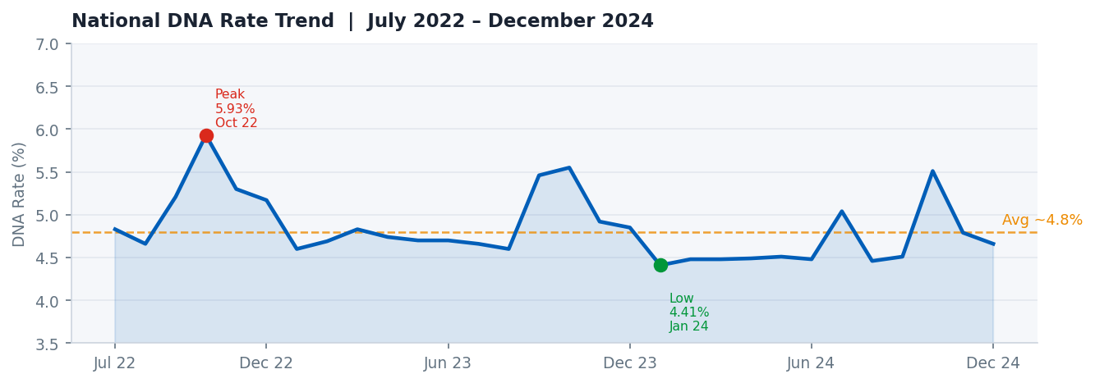
Figure 1 — National DNA rate trend, July 2022 – December 2024. Rates have remained broadly stable (4.41%–5.93%) with no persistent upward trajectory. Oct 2022 and Oct 2024 show seasonal spikes.
The national trend line is reassuring at a macro level: there is no systemic national crisis. A useful frame: think of it as analogous to a national average temperature: a stable national figure can coexist with a dangerous heatwave in one city and sub-zero temperatures in another. The regional picture reveals exactly this pattern.

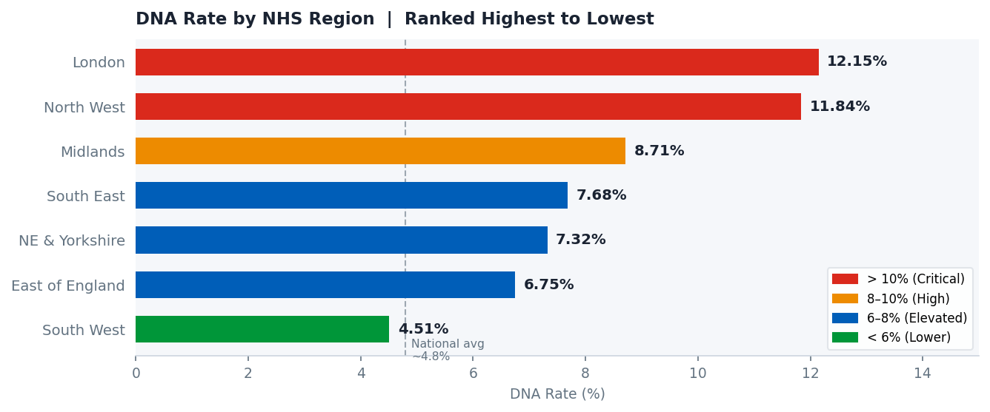
Figure 2 — DNA rate by NHS region. London and the North West are in a different tier from the other five regions, both exceeding 11%.
- London: 12.15% (513,023 DNAs from 4,223,020 appointments). The highest rate by a wide margin and 2.7× above South West.
- North West: 11.84% (182,335 DNAs from 1,540,415 appointments). Close behind London and host to five of the top ten worst Sub-ICBs nationally.
- Midlands: 8.71%, substantially above the national average, with significant internal variation.
- South West: 4.51%, the best performing region, notable given it contains the nationally outlying Sub-ICB in Bristol (21.84%).

Sub-ICB Variation
At Sub-ICB level, the spread is extreme. The following league table shows the ten highest and ten lowest DNA rate Sub-ICBs nationally, drawn from the full 96-location dataset.

Sub-ICB | Region | DNA % | Appointments
NHS Staffordshire & Stoke-on-Trent — 05Q | Midlands | 32.84% | 974 / 2,966
NHS Bristol, N.Somerset & S.Gloucestershire | South West | 21.84% | 45 / 206
NHS Hertfordshire & West Essex — 06N | East of England | 21.49% | 14,422 / 67,107
NHS Bucks, Oxon & Berkshire West — 14Y | South East | 17.35% | 656 / 3,780
NHS Cheshire & Merseyside — 99A | North West | 16.93% | 277 / 1,636
NHS Lancashire & South Cumbria — 02G | North West | 15.54% | 8,031 / 51,693
NHS Greater Manchester — 14L | North West | 14.88% | 27,365 / 183,885
NHS Staffordshire & Stoke-on-Trent — 05W | Midlands | 14.72% | 8,682 / 58,972
NHS Lancashire & South Cumbria — 01A | North West | 14.67% | 20,253 / 138,094
NHS Coventry & Warwickshire | Midlands | 14.59% | 41,456 / 284,223
Table 1 — Top 10 highest DNA rate Sub-ICBs. Note that 05Q (32.84%) is a significant outlier driven by very low appointment volumes (2,966); its rate warrants investigation but should be interpreted cautiously.

Sub-ICB | Region | DNA % | Appointments
NHS Humber & North Yorkshire — 03H | NE & Yorkshire | 0.00% | 0 / 12
NHS Suffolk & North East Essex — 07K | East of England | 0.00% | 0 / 275
NHS Suffolk & North East Essex — 06L | East of England | 2.21% | 839 / 37,883
NHS Mid & South Essex — 99E | East of England | 2.59% | 4,175 / 161,228
NHS Mid & South Essex — 99F | East of England | 3.18% | 2,707 / 85,125
NHS West Yorkshire — 03R | NE & Yorkshire | 3.23% | 2,353 / 72,920
NHS Cornwall & Isles of Scilly | South West | 3.27% | 89 / 2,718
NHS Sussex — 97R | South East | 3.30% | 2,032 / 61,635
NHS Dorset | South West | 3.35% | 6,538 / 194,928
NHS Hertfordshire & West Essex — 07H | East of England | 3.48% | 1,640 / 47,134
Table 2 — Bottom 10 lowest DNA rate Sub-ICBs. East of England features prominently among best performers.

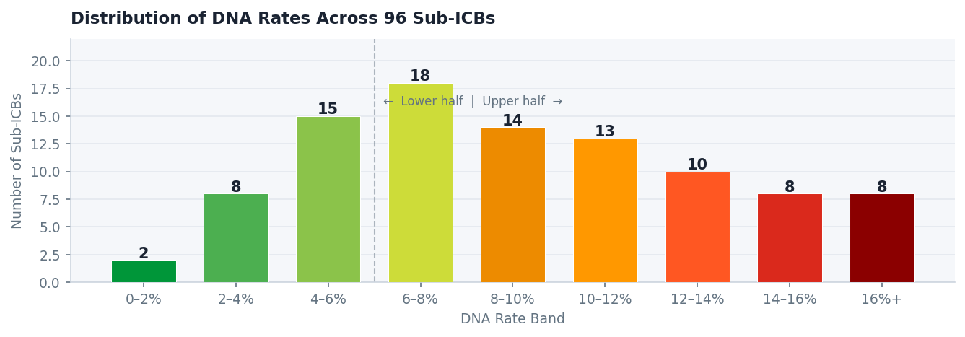
Figure 3 — Distribution of DNA rates across 96 Sub-ICBs. Roughly one third are below 6%, one third between 6–10%, and one third above 10%. The distribution is right-skewed, pulled upward by a tail of high-rate Sub-ICBs concentrated in London and the North West.

4.2 Q2 — Face-to-Face Has the Highest DNA Rate; the Mode Shift Has Helped Attendance, Not Hurt It
The single strongest finding in this analysis is the relationship between appointment mode and DNA rate. Face-to-face appointments have a DNA rate of 10.65%: 1.8× higher than telephone (5.77%), 4× higher than home visits (2.68%), and 5.5× higher than video/online appointments (1.94%).
This is not a marginal difference. It holds consistently across all seven regions and is present in the full 30-month dataset. The direction of the finding also contradicts a common assumption: that remote appointments are harder to attend because they require patients to manage technology or find a private space. The data suggests the opposite.

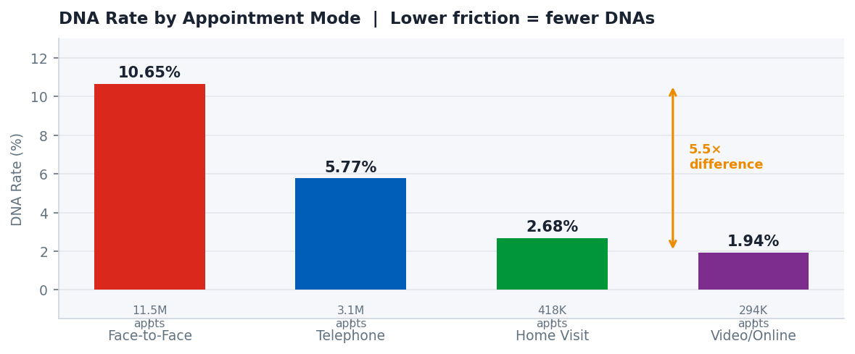
Figure 4 — DNA rate by appointment mode. Face-to-face is over 5× higher than video/online. Note the volume beneath each bar: face-to-face accounts for 11.5M appointments in this dataset vs 294K for video/online.
Cancellation Friction, Not Travel Cost, Best Explains the Pattern
The most coherent explanation is not that face-to-face appointments are harder to get to (the 'travel cost' hypothesis), but that they are harder to silently abandon. A face-to-face booking carries an implicit social contract: missing it requires a conscious choice to leave a slot empty, whereas a telephone or video appointment can be quietly ignored without the same psychological barrier.
This mirrors a well-documented behavioural pattern in service industries: people are more likely to abandon an online shopping cart than walk out of a physical shop mid-purchase. The 'friction' that matters is at the exit, not the entrance.
The travel cost hypothesis (that patients in less affluent areas cannot afford bus fares or fuel) is not straightforwardly supported by the deprivation data (Section 4.3). The corrected analysis shows that the most deprived Sub-ICBs do have higher average DNA rates, which is at least consistent with a travel cost effect. The relationship is non-monotonic, though, and within-band variation is so large that travel cost alone cannot account for the pattern observed. Appointment mode mix and urban density remain stronger candidates as primary structural drivers.

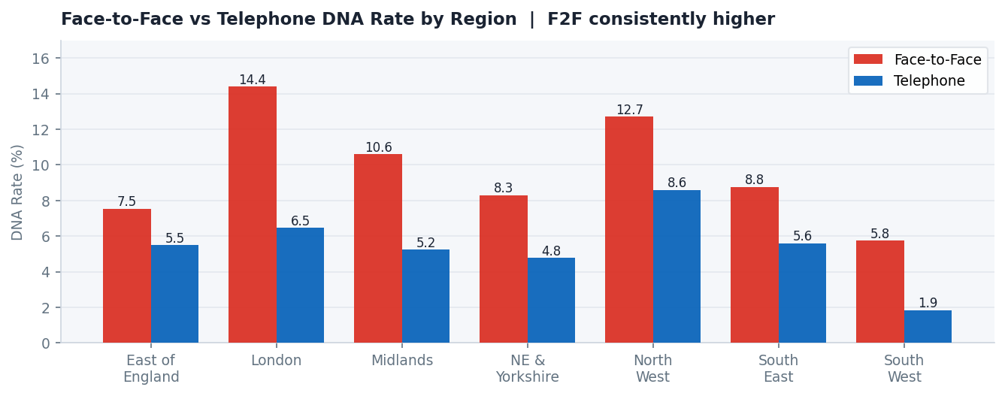
Figure 5 — Face-to-face vs telephone DNA rate by region. F2F consistently exceeds telephone in every region. The North West's telephone DNA rate (8.60%) exceeds the face-to-face rate in the South West (5.76%), showing that regional factors compound the mode effect.
The Mode Shift Has Already Cut DNAs — Digital Growth Is an Untapped Lever
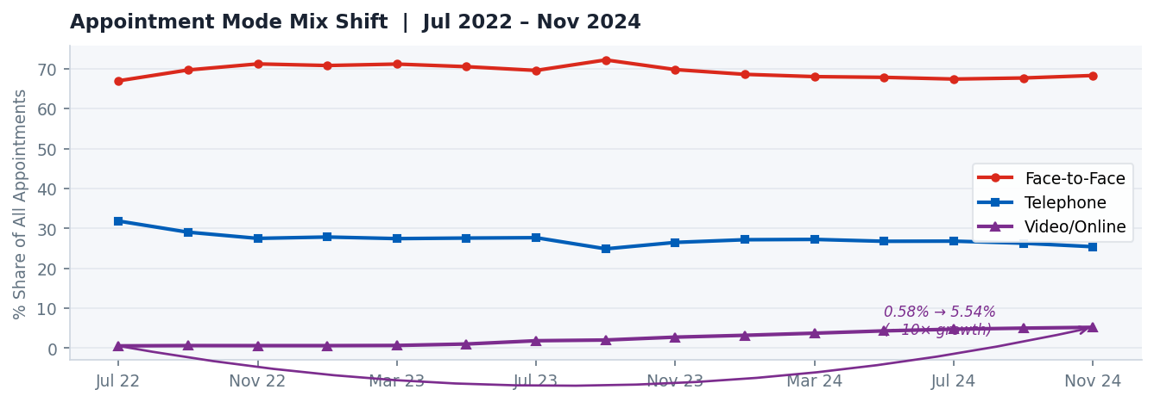
Figure 6 — Appointment mode mix over time. Face-to-face has remained broadly stable around 67–72%. Telephone has gradually declined. Video/online has grown from 0.58% to 5.23% of all appointments.

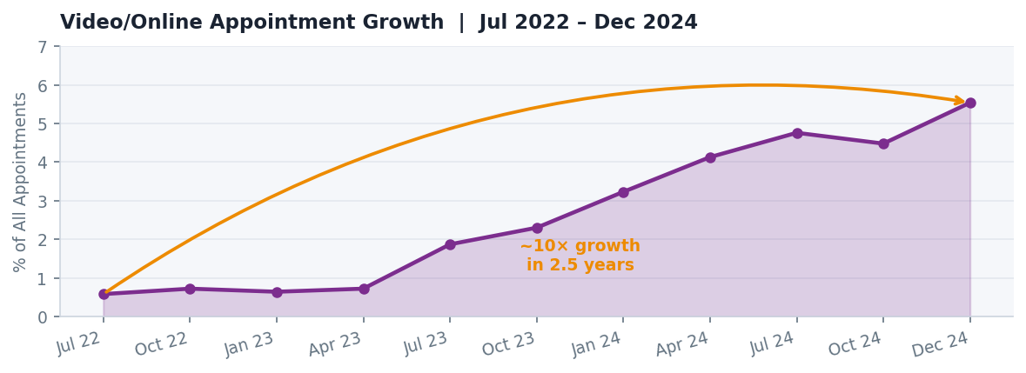
Figure 7 — Video/online appointment share, July 2022 – December 2024. Growth from 0.58% to 5.54% represents a near 10× increase. The trajectory is consistent and accelerating.

- Video/online appointments grew from 0.58% of all appointments (Jul 2022) to 5.54% by December 2024, a near 10-fold increase in 2.5 years.
- Despite this growth, video/online still accounts for less than 6% of all appointments. Face-to-face (at ~67%) remains dominant.
- If video/online share doubled from 5.54% to 11%, and face-to-face fell commensurately, the blended national DNA rate would drop by an estimated 0.3–0.5 percentage points, equivalent to tens of thousands of avoided missed appointments annually.

4.3 Q3 — Deprived Areas Have Higher DNA Rates; the Signal Is Real but Too Noisy to Drive Targeting Without Controlled Analysis
The original framing of this question assumed a positive relationship between deprivation and DNA rates, consistent with the existing literature on healthcare access barriers. The corrected analysis, using the ONS LSOA (2011) to Sub-ICB Locations lookup rather than an approximate name match, now covers all 96 Sub-ICBs and produces a materially different result from an earlier draft of this analysis.

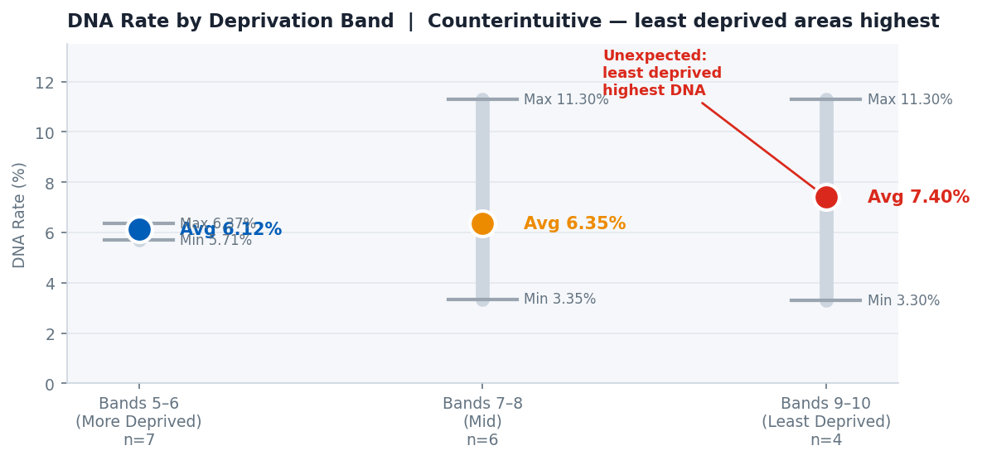
Figure 8 — DNA rate by deprivation band (corrected LSOA join, all 96 Sub-ICBs). The most deprived Sub-ICBs (band 3–4) have the highest average DNA rate at 11.24%. Note: band 9–10 contains a single Sub-ICB (Buckinghamshire 14Y, 17.35%) and should be treated as a data point rather than a band average.
Deprivation Band | Areas (n) | Avg DNA % | Min DNA % | Max DNA %
Bands 3–4 (Most Deprived) | 20 | 11.24% | 4.78% | 16.93%
Bands 5–6 (Mid) | 43 | 8.10% | 0.00% | 14.67%
Bands 7–8 | 32 | 8.83% | 0.00% | 32.84%
Bands 9–10 (Least Deprived) | 1 | 17.35% | 17.35% | 17.35%
Table 3 — DNA rate by IMD deprivation band (corrected LSOA join, all 96 Sub-ICBs). The most deprived band (3–4) has the highest average DNA rate at 11.24%. Band 9–10 contains one Sub-ICB only (Buckinghamshire 14Y, 17.35%) and should not be read as a band average. The very wide within-band DNA ranges across all bands indicate that deprivation is an imperfect predictor at Sub-ICB level.

The corrected data provides partial support for the access inequality hypothesis. The most deprived Sub-ICBs (band 3–4, 20 areas) have the highest average DNA rate at 11.24%, and this band includes some of England's most recognisable high-deprivation areas: Lancashire (13.65%), Greater Manchester (14.88%), and Cheshire (16.93%). Three qualifications prevent a simple interpretation. First, the pattern is non-monotonic: band 7–8 (8.83%) has a higher average than band 5–6 (8.10%), indicating that deprivation alone cannot predict DNA rates in a linear fashion. Second, the within-band ranges are very wide in every band: band 7–8 spans 0.00% to 32.84%, meaning the band average is not representative of any specific Sub-ICB. Third, band 9–10 contains a single Sub-ICB (Buckinghamshire 14Y, 17.35%), which cannot be interpreted as a broader trend for more affluent areas.
What the corrected data shows is that the most deprived Sub-ICBs do tend toward higher DNA rates, lending qualified support to the access inequality narrative. But the relationship is imperfect. The highest-DNA Sub-ICBs are concentrated in London and the North West, driven by urban density, transient populations, and same-day triage mode mix, not deprivation alone. No commissioning decision should rest on this deprivation signal without first controlling for appointment mode mix, urban classification, and booking lead time. These confounds likely explain a substantial share of the DNA difference between bands.

5. Limitations
- The Sub-ICB level data covers appointments recorded through Primary Care Network hub systems rather than all GP practice appointment systems. The geographic analysis may not represent all GP appointments in each Sub-ICB area. The national trend analysis uses the broader GP practice-level National Overview dataset (30 months, July 2022 – December 2024), which provides greater coverage.

- The deprivation analysis was re-run during this project after the initial version used an approximate text-based match between Sub-ICB and Local Authority names, which produced materially incorrect results. The final analysis uses the ONS LSOA (2011) to Sub-ICB Locations (July 2022) lookup, joining 32,844 LSOAs to Sub-ICB codes via LSOA11CD → SICBL22CDH and covering all 96 Sub-ICBs. A residual structural limitation is that band 9–10 represents a single Sub-ICB (Buckinghamshire 14Y) and cannot be generalised. Appointment booking lead time is a confound not captured in this dataset: same-day triage telephone slots and advance-booked face-to-face appointments have structurally different DNA dynamics, and a high face-to-face DNA rate may partly reflect a practice's booking model rather than patient behaviour. Patient selection into appointment mode (clinically complex patients are typically directed to face-to-face) further complicates mode-level comparison. This analysis covers primary care only and should not be extrapolated to secondary care settings.

- The deprivation data used is from the 2019 release. Socioeconomic conditions have shifted since then. A 2025 IMD release exists but is not yet consistently mapped to the Sub-ICB geography used here.

- All relationships identified are observational. This analysis does not control for confounding variables such as practice size, patient demographics, clinical speciality mix, or local reminder system quality. The mode-DNA relationship in particular, while strong and consistent, would benefit from a controlled study design before informing major commissioning decisions.

- Two Sub-ICBs with 0.00% DNA rates have very low appointment volumes (12 and 275 appointments respectively), making their rates statistically unreliable. Similarly, the 32.84% rate in Staffordshire & Stoke-on-Trent 05Q is derived from only 2,966 appointments.

6. Recommendations
6.1 Accelerate the Shift to Lower-Friction Appointment Modes
The most actionable finding in this analysis is the 5.5× gap in DNA rates between face-to-face (10.65%) and video/online appointments (1.94%). Every percentage point shift in mode mix from face-to-face toward telephone or digital has a directly measurable impact on DNA rates.
- NHS commissioners should set explicit targets for video/online appointment share at Sub-ICB level, building on the existing growth trajectory (0.58% to 5.54% since 2022).
- GP practices in high-DNA regions should be supported to expand telephone and video triage capacity, with particular focus on converting routine follow-up and review appointments to remote modes where clinically appropriate.
- Patient-facing communications should actively normalise digital and telephone appointments, addressing any perception that face-to-face is a higher quality of care.
Note: This recommendation deliberately does not suggest moving patients 'away from face-to-face' as a catch-all. Clinical appropriateness must remain the primary allocation criterion. The recommendation is to expand the pathway for appointments that are clinically suitable for remote delivery.
6.2 Target London and North West for Regional DNA Reduction Programmes
London (12.15%) and North West (11.84%) together account for a disproportionate share of national DNAs. Within the North West, five of the ten worst Sub-ICBs cluster in Greater Manchester, Lancashire, and Cheshire, suggesting systemic regional factors rather than isolated GP-level issues.
- NHS England should commission a dedicated regional review in London and the North West, examining mode mix, practice-level reminder systems, appointment booking lead times, and demographic factors including transient and non-English speaking populations.
- Sub-ICBs in the top decile nationally should be required to produce DNA reduction plans with measurable targets, reviewed at quarterly ICB performance cycles.
- Best-practice sharing between the lowest-performing and highest-performing Sub-ICBs should be facilitated, particularly learning from the East of England (6.75% average, with several Sub-ICBs below 3.5%).
6.3 Use the Deprivation Signal, But Validate With Controlled Analysis Before Acting
The corrected analysis shows that the most deprived Sub-ICBs do have the highest average DNA rate: band 3–4 averages 11.24%, with recognisable high-deprivation clusters in Lancashire, Greater Manchester, and Cheshire all reporting rates above 13%. This provides a more credible basis for targeted commissioning than an earlier draft of this analysis suggested. The relationship is non-monotonic, though, and within-band variation is too wide to support direct targeting without further controlled analysis.
- The band 3–4 Sub-ICBs in Lancashire, Greater Manchester, and Cheshire sit in the top quartile for both deprivation and DNA rate and are plausible targets for mode-shift interventions, alongside the broader London and North West focus recommended in Section 6.1. Before committing resources on the basis of this deprivation signal, NHS England should commission a controlled analysis accounting for appointment mode mix, urban/rural classification, and booking lead time. The current data is sufficient to form a hypothesis; it is not sufficient to act on it without that further step.
- DNA rate disaggregated by IMD decile should be added to NHS England's routine primary care performance monitoring framework, but only alongside appointment mode mix data. Publishing raw DNA-by-deprivation figures without mode adjustment risks misattributing what is partly a structural booking and friction problem to patient behaviour in deprived areas.
- The current framing of DNA reduction as an 'access inequality' issue should be tested more rigorously. The data here suggests it may be better characterised as a 'friction and commitment' issue, with implications for how interventions are designed.

7. Portfolio Notes for Reviewers
7.1 Skills Demonstrated
Skill Area | Evidence in This Project
Data Collection | Identified, evaluated, and downloaded four public NHS and ONS datasets independently
Data Cleaning (SQL) | Applied 6 documented cleaning transformations with full audit trail; handled nulls, casing, date formats, and invalid values
Exploratory Analysis | Ran systematic sense checks before and after cleaning; identified structural issues including the 'Booked' status problem and UNMAPPED rows
Descriptive Analysis | Calculated DNA rates, mode share, and deprivation-band averages using SQL aggregate functions including window functions (OVER / PARTITION BY)
Data Joining | Joined across three datasets with different geographic granularities; documented join limitations transparently
Data Visualisation | Designed chart outputs across multiple chart types; embedded in formal case study document
Critical Thinking | Revised research questions mid-project after data challenged original assumptions; distinguished correlation from causation; documented methodology decisions
Analytical Communication | Translated counterintuitive findings into clear, evidence-based recommendations directed at NHS England commissioners

8. Appendix — Data Sources & Access Links
Dataset | Publisher | Access URL
Appointments in General Practice (National Overview & PCN Granular) | NHS England | digital.nhs.uk/data-and-information/publications/statistical/appointments-in-general-practice
English Indices of Deprivation 2019 (File 7 — full combined CSV) | DLUHC / ONS | gov.uk/government/statistics/english-indices-of-deprivation-2019
GP Patient Survey 2024 (ICB-level results) | NHS England | gp-patient.co.uk/reporting-2024

All datasets are publicly available, free to access, and published under the Open Government Licence v3.0. No patient-identifiable data was used at any stage of this project.

